Ex: 03 LIBRARY MANAGEMENT SYSTEM Date: 29.12.2025
Name: Ajay Kumar S
Roll no: 2024503701
Aim:
To design library management system.
Description:
The webpage is created using various HTML and CSS tags to display book information in a structured table. JavaScript is used to fetch data from an XML file, dynamically generate HTML content, and interact with the webpage.
XML Concepts Used:
- Structured Data Storage –
XML is used to store book records in a structured, hierarchical format. Each <book> element contains details about a book.
- Elements –
Each book record has child elements such as <id>, <title>, <author>, <category>, <price>, and <status> to store respective information.
- Hierarchical Organization –
All <book> elements are wrapped inside a <library> root element, making it easy to manage and parse multiple book records.
- Data Retrieval –
JavaScript can fetch and parse XML using XMLHttpRequest to access each element’s content dynamically.
- Extensibility –
New books can be added to the XML file without changing the structure, making it flexible for future expansion.
JavaScript Concepts Used:
- AJAX (XMLHttpRequest) –
Used to fetch data from the XML file without reloading the webpage.
Code:

Index.html:
<!DOCTYPE html>
<html>
<head>
<title>Library Management </title>
</head>
<link rel="stylesheet" href="style.css">
<style>
body{
background-color: rgb(172, 189, 126);
}
</style>
<body>

<h1 class="title">Library Management System</h1>
<hr>
<nav class="container">

<h3> <a href="view.html"> View Books </a></h3>
<h3> <a href="add.html"> Add Books </a></h3>
</nav>
<marquee behavior="scroll" direction="left" scrollamount="40">
<img src="lib.jpg" alt="Library" width="700" height="700" style="margin-right: 20px;">
<img src="lib1.jpg" alt="Library" width="700" height="700" style="margin-right: 20px;">
<img src="lib2.jpg" alt="Books" width="700" height="700" style="margin-right: 20px;">
<img src="image1.png" alt="Image 1" width="700" height="700" style="margin-right: 20px;">
<img src="image2.png" alt="Image 2" width="700" height="700">
</marquee>
<hr>
</body>
<footer>
<div class="footer-content">
<p><b>Contact Us:</b></p>
<p>Email: library@example.com</p>
<p>Phone: +1 234 567 890</p>
<p>Address: 123 Library Street, Booktown</p>
</div>
</footer>
View.html:
<!DOCTYPE html>
<html lang="en">
<head>
<meta charset="UTF-8">
<meta name="viewport" content="width=device-width, initial-scale=1.0">
<title>View Books</title>
<link rel="stylesheet" href="style.css">
</head>
<style>
body{
background-color: rgb(172, 189, 126);
}
</style>
<body>
<h1 class="title">Library Management System</h1>
<hr>
<tabel id="output"></tabel>
<script src="script.js"></script>
</body>
</html>
</html>
Add.html:
<!DOCTYPE html>
<html lang="en">
<head>
<meta charset="UTF-8">
<meta name="viewport" content="width=device-width, initial-scale=1.0">
<title>Add Books</title>
<link rel="stylesheet" href="style.css">
</head>
<style>
body{
background-color: rgb(172, 189, 126);
}
</style>
<body>
<h1 class="title">Library Management System</h1>
<hr>
<form method="post" action="add.html" class="form">
<h2>Add Book</h2>
<label for="id">ID:</label><br>
<input type="text" id="id"><br><br>
<label for="title">Title:</label><br>
<input type="text" name="title" id="title"><br><br>
<label for="author">Author:</label><br>
<input type="text" name="author" id="author"><br><br>
<label for="category">Category:</label><br>
<input type="text" name="category" id="category"><br><br>
<label for="price">Price:</label><br>
<input type="number" name="price" id="price"><br><br>
<label for="status">Status:</label><br>
<input type="text" name="status" id="status"><br><br>
<input type="submit" value="Add" onclick="add()">
</form>
<script src="script.js"></script>
<hr>
</body>
</html>
Library.xml:
<?xml version="1.0" encoding="UTF-8"?>
<library>
<book>
<id>101</id>
<title>Clean Code</title>
<author>Robert C. Martin</author>
<category>Programming</category>
<price>$450</price>
<status>Available</status>
</book>
<book>
<id>102</id>
<title>Introduction to Algorithms</title>
<author>Thomas H. Cormen</author>
<category>Computer Science</category>
<price>$850</price>
<status>Issued</status>
</book>
<book>
<id>103</id>
<title>Design Patterns</title>
<author>Erich Gamma</author>
<category>Software Engineering</category>
<price>$650</price>
<status>Available</status>
</book>
<book>
<id>104</id>
<title>Operating System Concepts</title>
<author>Silberschatz</author>
<category>Operating Systems</category>
<price>$720</price>
<status>Issued</status>
</book>
<book>
<id>105</id>
<title>Computer Networks</title>
<author>Andrew S. Tanenbaum</author>
<category>Networking</category>
<price>$680</price>
<status>Available</status>
</book>
<book>
<id>106</id>
<title>Database System Concepts</title>
<author>Abraham Silberschatz</author>
<category>Database</category>
<price>$700</price>
<status>Issued</status>
</book>
<book>
<id>107</id>
<title>Java: The Complete Reference</title>
<author>Herbert Schildt</author>
<category>Programming</category>
<price>$550</price>
<status>Available</status>
</book>
<book>
<id>108</id>
<title>Python Crash Course</title>
<author>Eric Matthes</author>
<category>Programming</category>
<price>$480</price>
<status>Available</status>
</book>
<book>
<id>109</id>
<title>Artificial Intelligence</title>
<author>Stuart Russell</author>
<category>AI</category>
<price>$900</price>
<status>Issued</status>
</book>
<book>
<id>110</id>
<title>Machine Learning</title>
<author>Tom Mitchell</author>
<category>AI</category>
<price>$820</price>
<status>Available</status>
</book>
<book>
<id>111</id>
<title>Web Technologies</title>
<author>Ullman</author>
<category>Web Development</category>
<price>$400</price>
<status>Available</status>
</book>
<book>
<id>112</id>
<title>Software Testing</title>
<author>Ron Patton</author>
<category>Software Engineering</category>
<price>$460</price>
<status>Issued</status>
</book>
<book>
<id>113</id>
<title>Cloud Computing</title>
<author>Rajkumar Buyya</author>
<category>Cloud</category>
<price>$780</price>
<status>Available</status>
</book>
<book>
<id>114</id>
<title>Cyber Security Essentials</title>
<author>Charles J. Brooks</author>
<category>Security</category>
<price>$620</price>
<status>Available</status>
</book>
<book>
<id>115</id>
<title>Data Science Handbook</title>
<author>Jake VanderPlas</author>
<category>Data Science</category>
<price>$860</price>
<status>Issued</status>
</book>
</library>
Script.js:
const xhttp = new XMLHttpRequest();

xhttp.onload = function () {
const xmlDoc = this.responseXML;
const books = xmlDoc.getElementsByTagName("book");
let output = `
<table border="1" cellspacing="0" cellpadding="8" class='tbl'>
<thead>
<tr>
<th>ID</th>
<th>Title</th>
<th>Author</th>
<th>Category</th>
<th>Price</th>
<th>Status</th>
</tr>
</thead>
<tbody>
`;

for (let i = 0; i < books.length; i++) {
const id = books[i].getElementsByTagName("id")[0].textContent;
const title = books[i].getElementsByTagName("title")[0].textContent;
const author = books[i].getElementsByTagName("author")[0].textContent;
const category = books[i].getElementsByTagName("category")[0].textContent;
const price = books[i].getElementsByTagName("price")[0].textContent;
const status = books[i].getElementsByTagName("status")[0].textContent;
output += `
<tr>
<td>${id}</td>
<td>${title}</td>
<td>${author}</td>
<td>${category}</td>
<td>${price}</td>
<td>${status}</td>
</tr>
`;
}
output += `
</tbody>
</table>
`;
document.getElementById("output").innerHTML = output;
};
xhttp.open("GET", "library.xml", true);
xhttp.send();
function add(){
alert("Book Added Successfully...");
}
Output:


Figure(a)
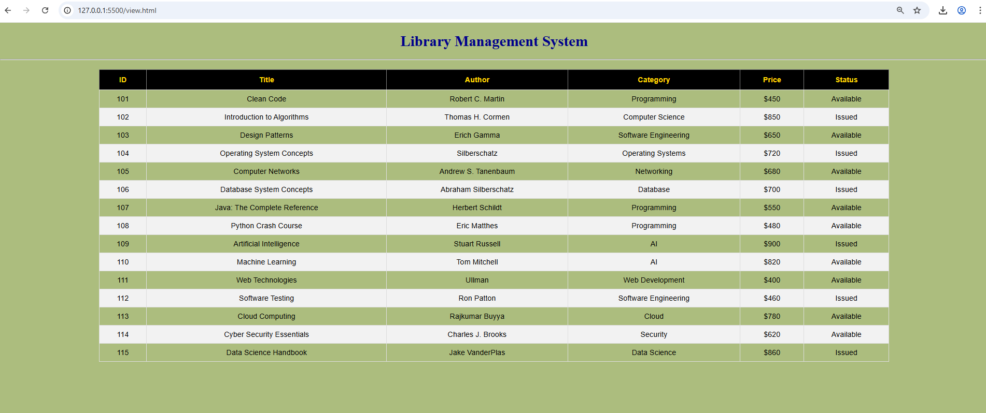
Figure(b)

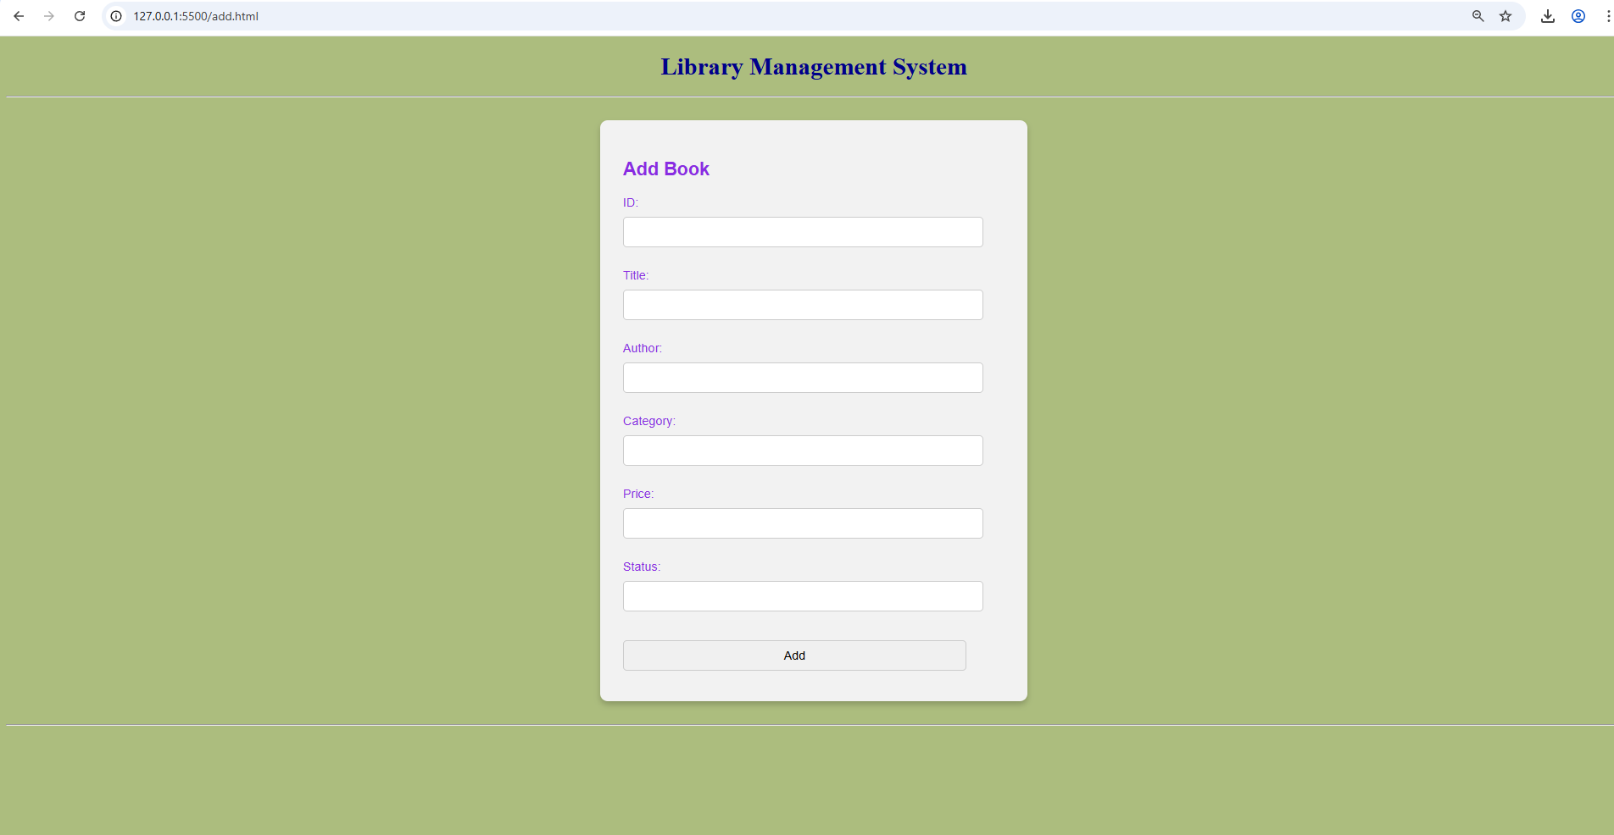
Figure(c)
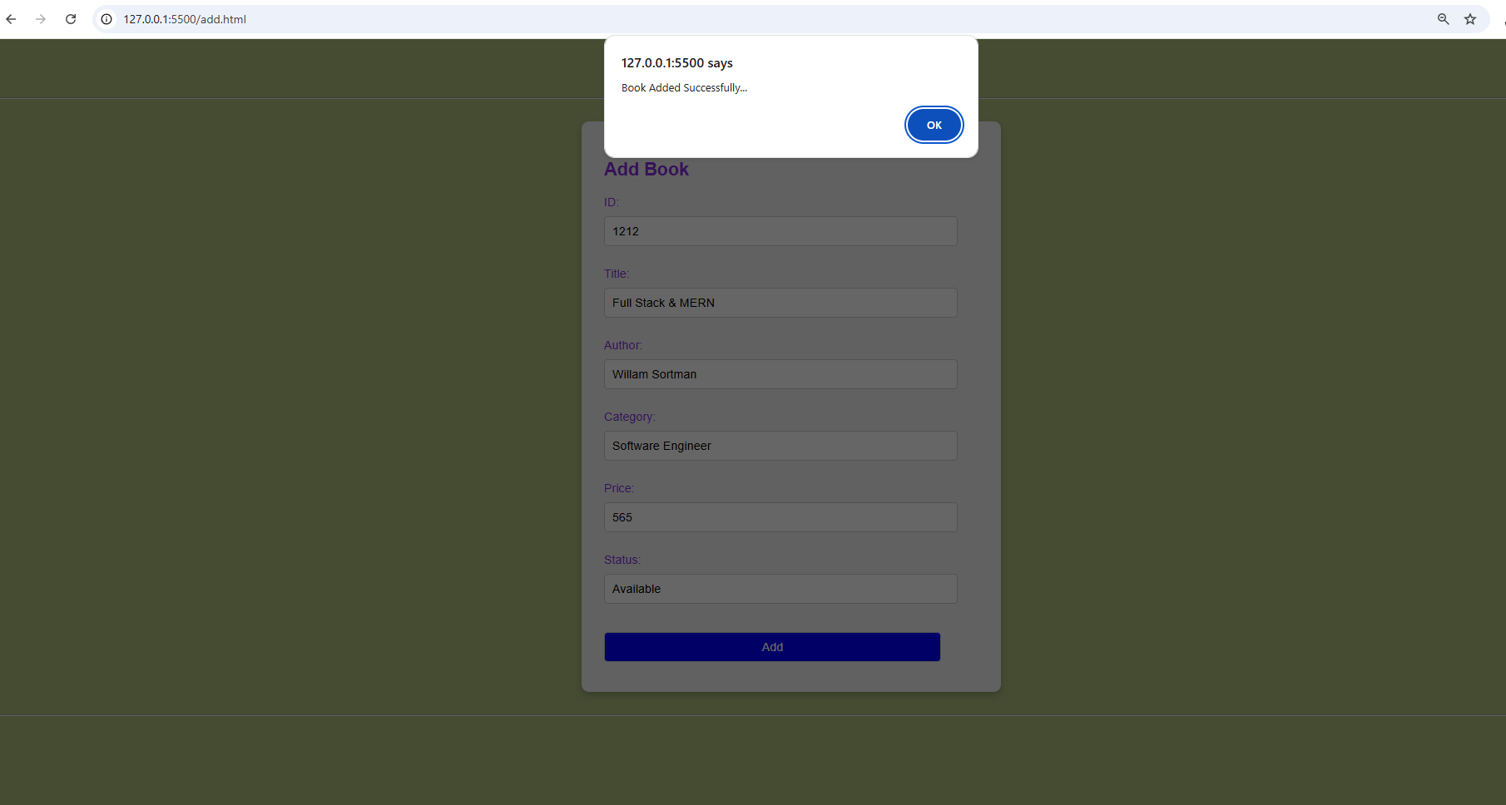
Figure(d)

Result:
Thus, the library management system is done and the output is taken successfully by performing add, and display operations.

